Step 1)

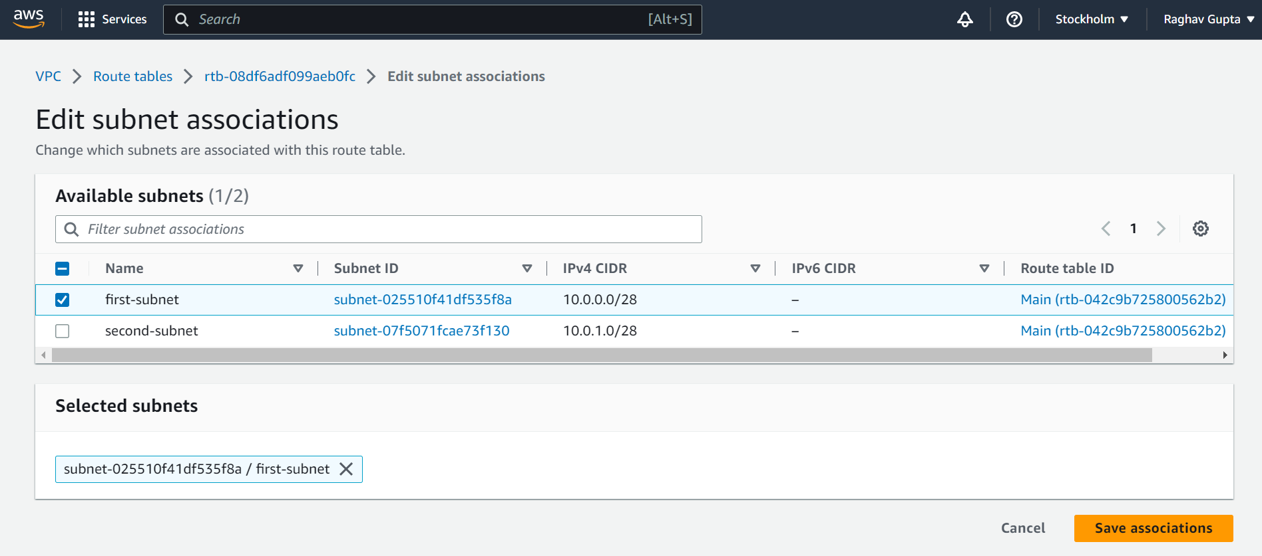

Step-2)

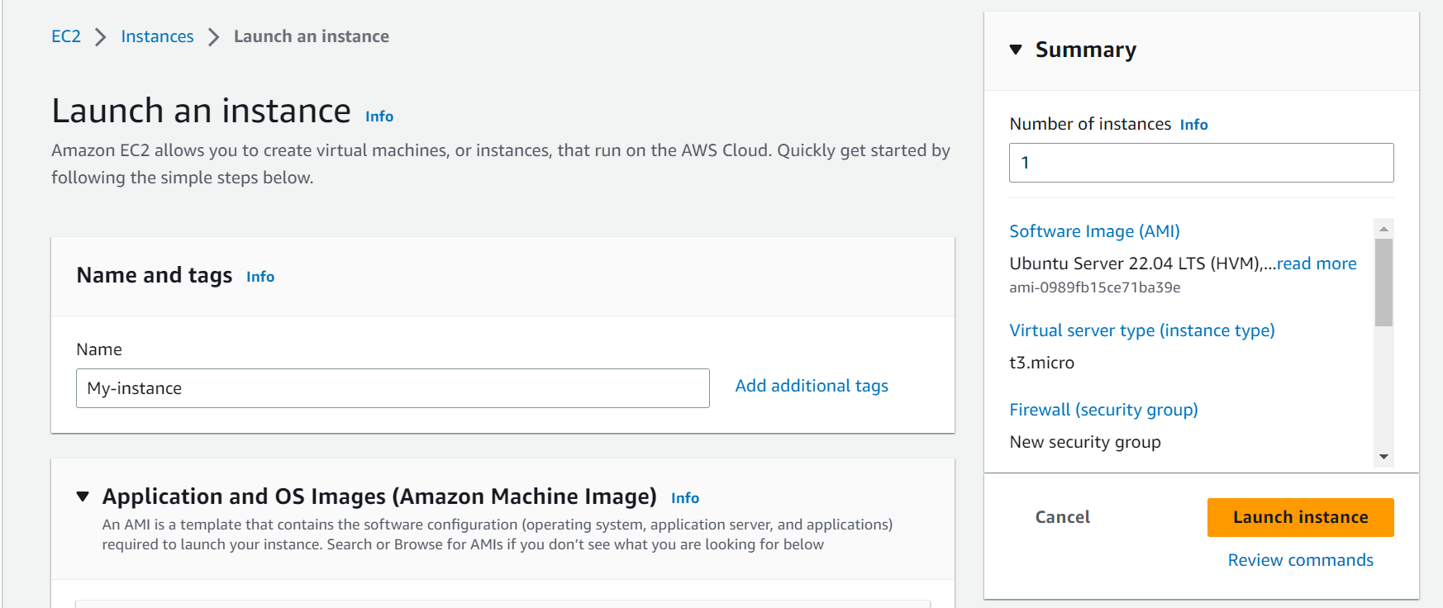

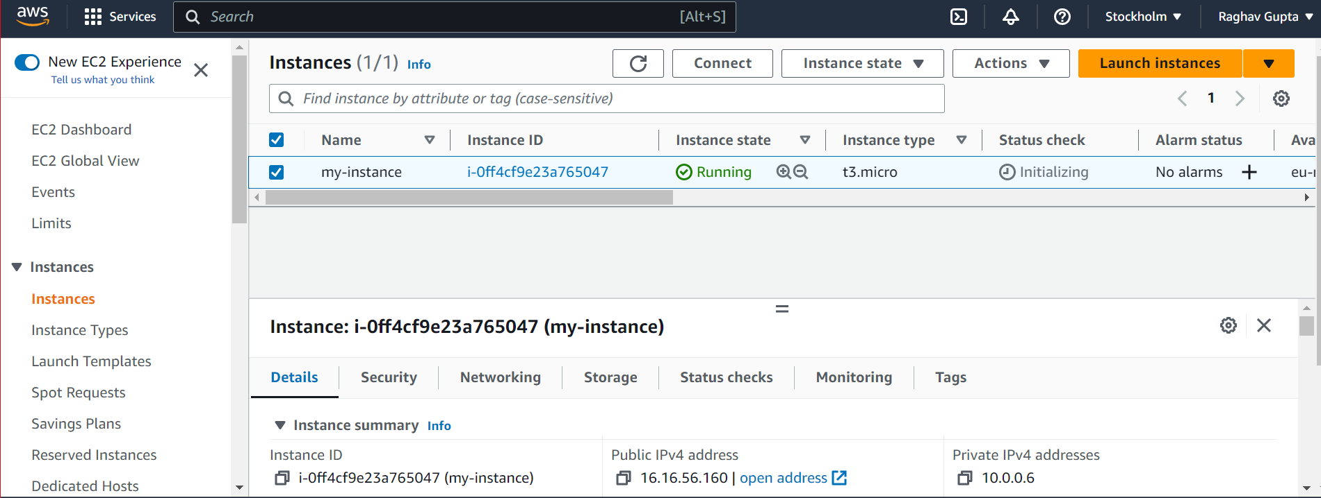

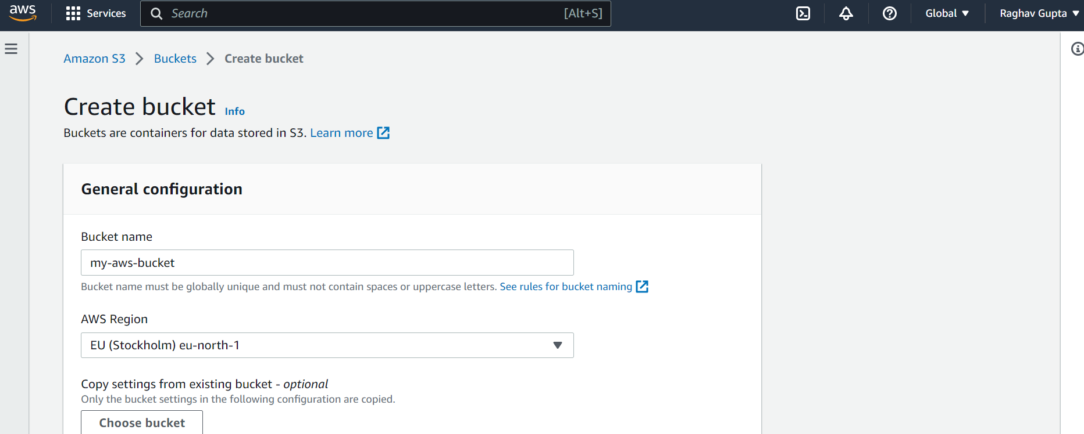

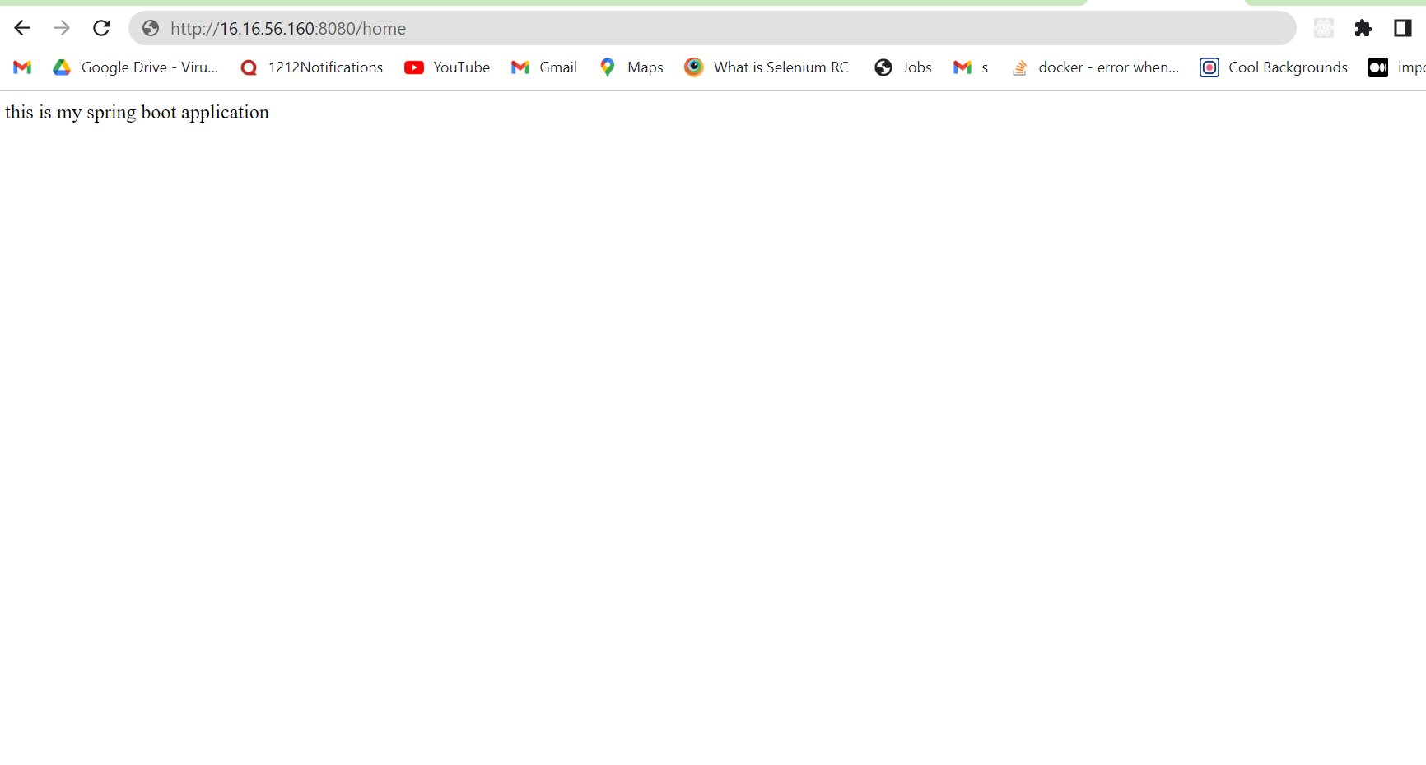

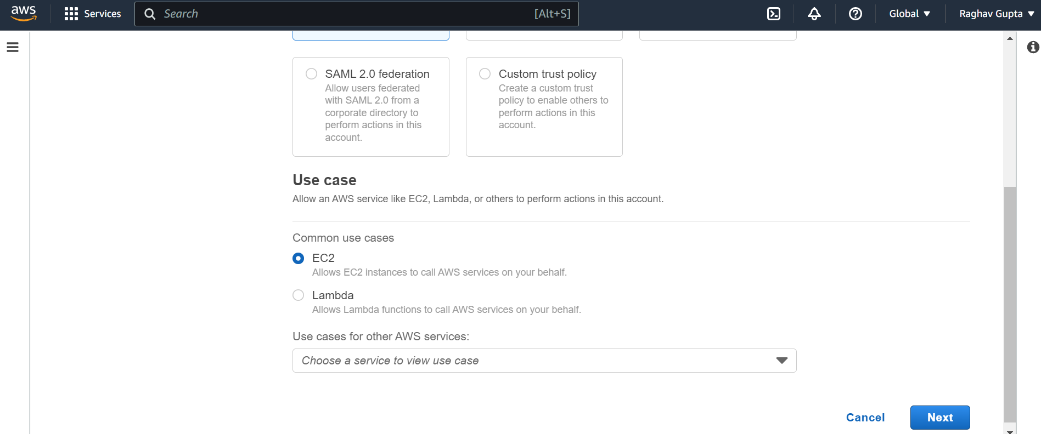

Step3)

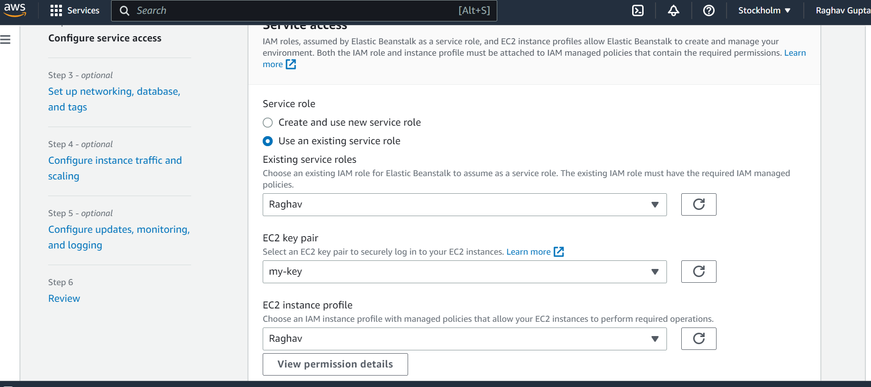

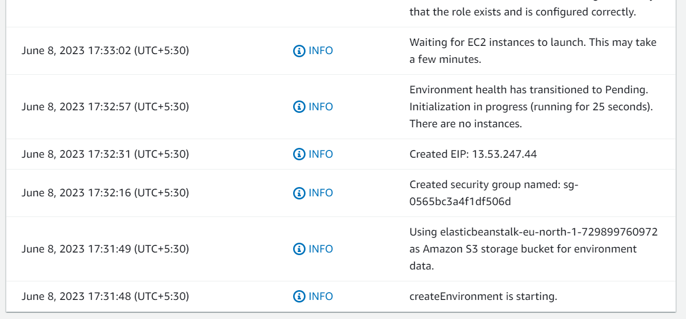

Step4)

Creating trigger

Uploaded projects